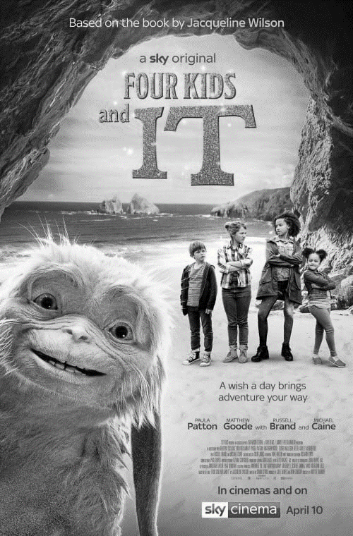

The title **font** is in **bold**,tall **capitals**, in the **genre** of adventure movies. The title is **framed** by the rocks and the **white space** of the sky, drawing **focus** to it. **Focus** is also drawn to “IT”, who is **positioned** in the bottom left, by its outline being **highlighted** with light. **Balancing** this, the four kids are on the right, and in **contrast** they are in the middle distance.

|  |  |  |  |
| --- | --- | --- | --- |
| **D** | **Key Vocab** | | |
|  | | **Contrast** | **Bold** |
|  | | **Emphasise** | **Capitals** |
|  | | **Framing** | **Classic** |
|  | | **Highlight** | **Simple** |
|  | | **Symmetry** | **Genre** |
|  | | **Centred** | **Target audience** |
|  | | **Perspective** |
|  | |  |  |
|  | |  | |
|  | |  | |
|  | |  | |
|  | |  | |
|  | |  | |
|  | |  | |
|  | |  | |
|  | |  | |
|  | |  | |

Name:

R082: Digital Graphics Uses and Content

|  |  |  |  |
| --- | --- | --- | --- |
| **B** | | **Design and Layout Vocab** | |
| **Colour** | | | |
| **1** | **Warm** | | Red, orange, yellow. Bright, energetic |
| **2** | **Cool** | | Blue, green, purple. Settling and calm |
| **3** | **Neutral** | | Beige, cream, ivory. Avoids attention |
| **Composition** | | | How a digital graphic is set out, including: |
| **1** | **Positioning** | | Where objects are placed relative to each other |
| **2** | **Focus** | | How lines and perspective draw attention to certain areas |
| **3** | **Balance** | | Which parts are similar to each other and which parts contrast |
| **4** | **Font** | | Lettering style |
| **5** | **White space** | | Any block of solid colour where there are no elements |

|  |  |  |  |
| --- | --- | --- | --- |
| **C** | | **Purposes of Digital Graphics** | |
| **1** | **To entertain** | | To amuse or provide enjoyment |
| **2** | **To advertise** | | To promote a product |
| **3** | **To promote** | | To give publicity to an idea, person, company etc *(eg NHS health campaign)* |
| **4** | **To inform** | | To give information *(eg signage)* |
| **5** | **To educate** | | To give information and understanding about a topic *(eg infographic)* |

|  |  |  |  |
| --- | --- | --- | --- |
| **A** | | **Uses of Digital Graphics** | |
| **1** | **Print publishing** | | eg Magazines, leaflets, books, newspapers, posters |
| **2** | **Labelling** | | eg ingredients, health warnings, |
| **3** | **Branding** | | eg Logos, Trademark images |
| **4** | **Advertising** | | eg *printed:* billboards, poster eg *online:* banner ads |
| **5** | **Websites** | | eg backgrounds, borders, buttons |
| **6** | **Presentations** | | eg infographics |
| **7** | **Games** | | eg box covers, images used in-game |

|  |  |  |
| --- | --- | --- |
| **A** | **Key Vocab** | |
| **Compression** | | Reduction of a file size either by removing information (lossy) or without removing information (lossless) |
| **Lossy** | | Compression of a file which loses some original data |
| **Lossless** | | Compression of a file which keeps all the original data |
| **Pixel** | | A single point of colour which makes up a bitmap image |
| **Vector** | | A method of storing an image. Details of where lines start and end, fills and colours are stored. Looks smooth when enlarged |
| **Bitmap** | | A method of storing an image. Each pixel’s value and position is recorded. Looks pixelated when enlarged |
| **Raster** | | Same as bitmap |

|  |  |  |
| --- | --- | --- |
| **B** | **Property Definitions** | |
| **Digital graphic property** | | The features of a digital graphic file (as opposed to the composition) which make it suitable for different uses |
| **Resolution** | | The number of pixels in a certain area, often measured in dpi |
| **DPI** | | Dots per inch. A measure of resolution. The number of pixels in an inch. |
| **File Type** | | The way an image is stored on the computer eg GIF |
| **File Extension** | | eg .gif at the end of the file name |
| **Dimensions** | | The width and the height of the image, measured either in pixels or in mm |
| **Download speed** | | Smaller file sizes download faster. Larger images download slower |
| **Picture quality** | | Smaller, more compressed files are lower quality. Larger files are higher quality |

R082: Properties of Digital Graphics

Name:

|  |  |  |  |  |  |
| --- | --- | --- | --- | --- | --- |
| **C** | | **Properties of images** | | | |
| **Property** | | | | **Made for the web** | **Made for print** |
| **1** | **Resolution** | | Measured in dpi | Low resolution – 72dpi | High resolution – 300 dpi |
| **2** | **Colours** | | How many colours the image can support | eg GIF has 256 | Millions of colours |
| **3** | **File size** | | Measured in MegaBytes (MB) | Small for lower download times | large for higher quality |
| **4** | **Dimensions** | | Width x Height | Measured in px | Measured in mm |
| **5** | **Compression** | | How the file is compressed | High compression for smaller file | Little or no compression |
| **6** | **File Type** | | Same as *file format* and *file extension* | eg GIF, JPG, PNG | eg RAW, TIFF, EPS, BMP |

|  |  |  |  |  |  |  |  |  |  |
| --- | --- | --- | --- | --- | --- | --- | --- | --- | --- |
| **D** | **File types** | | | | | | | | |
| **PDF** | | document | lossless | cannot be edited |  | **MPEG** | video | lossy | high quality video |
| **DOCX** | | document | lossless | Word file |  | **MP4** | video | lossy | good for streaming online |
| **TXT** | | document | lossless | text only, no formatting |  | **MOV** | video | lossy | Quicktime Media Player format |
| **PNG** | | image | lossless | good compression for graphics |  | **MP3** | audio | lossy | high compression rate |
| **JPEG** | | image | lossy | good compression for images |  | **WAV** | audio | lossless | uncompressed |
| **GIF** | | image | lossy | normally used for animations |  | **SWF** | animation | lossy | good for streaming online |
| **BMP** | | image | lossless | uncompressed |  | **GIF** | animation | lossy | limited colour support |
| **SVG** | | image | lossless | cross application vector format |  | **FLV** | animation | lossy | Flash animation |
| **TIFF** | | image | both | high resolution raster images |  | **MOV** | animation | lossy | video formats can also be used |

|  |  |  |
| --- | --- | --- |
| **A** | **Storing Digital Graphics vocab** | |
| **Lossy** | | Compression of a file which loses some original data |
| **Lossless** | | Compression of a file which keeps all the original data |
| **Pixel** | | A single point of colour which makes up a bitmap image |
| **Resolution** | | The number of pixels in a certain area, often measured in dpi |
| **DPI** | | Dots per inch. A measure of resolution. The number of pixels in an inch. |
| **Compression** | | Reduction of a file size either by removing information (lossy) or without removing information (lossless) |
| **Bitmap** | | A method of storing an image. Each pixel’s value and position is recorded. Looks pixelated when enlarged |
| **Raster** | | Same as bitmap |
| **Vector** | | A method of storing an image. Details of where lines start and end, fills and colours are stored. Looks smooth when enlarged |

R082: Storing Digital Graphics

Name:

|  |  |  |
| --- | --- | --- |
| **B** | **Working at a Computer** | |
| **Chair height** | | Eyes level with the display |
| **Seating position** | | Straight back, thighs parallel to the ground |
| **Distance from eyes to screen** | | About 50-60cm |
| **Breaks** | | Take a break for 1-2 mins every half hour to stretch |

|  |  |  |
| --- | --- | --- |
| **C** | **Version Control** | |
| **Version Numbering** | | Graphics_mindmap_Ver1  Graphics_mindmap_Ver2  Graphics_mindmap_Ver3 |
| **Date code version control** | | Mitzy_script_22.1.20  Mitzy_script_29.1.20  Mitzy_script_3.2.20 |